Animal Trailer Launch

The Idea - Trailer launches happen all the time and mostly the are organised in a similar manner. The best way to make an impact would be to follow the theme of the movie. It will not only connect with the crowd but also give the media a lot of things to cover.
It will be picked up by fans and media alike and they would appreciate the marketing as generally it does not happen this way.

The Launch

Music plays, possibly from the Pre-Teaser and men come running through the crowd with masks on (again from the pre-teaser) towards the stage. The men would then surround the stage, the ones in the front may sit in the kneel down position so that they don’t block the view.

Whistling music from the announcement video plays and Ranbir enters.
- if the venue allows the possibility on an isle, like that of a red carpet entrance, it would Ranbir may make the entrance walking and waving to the crowd
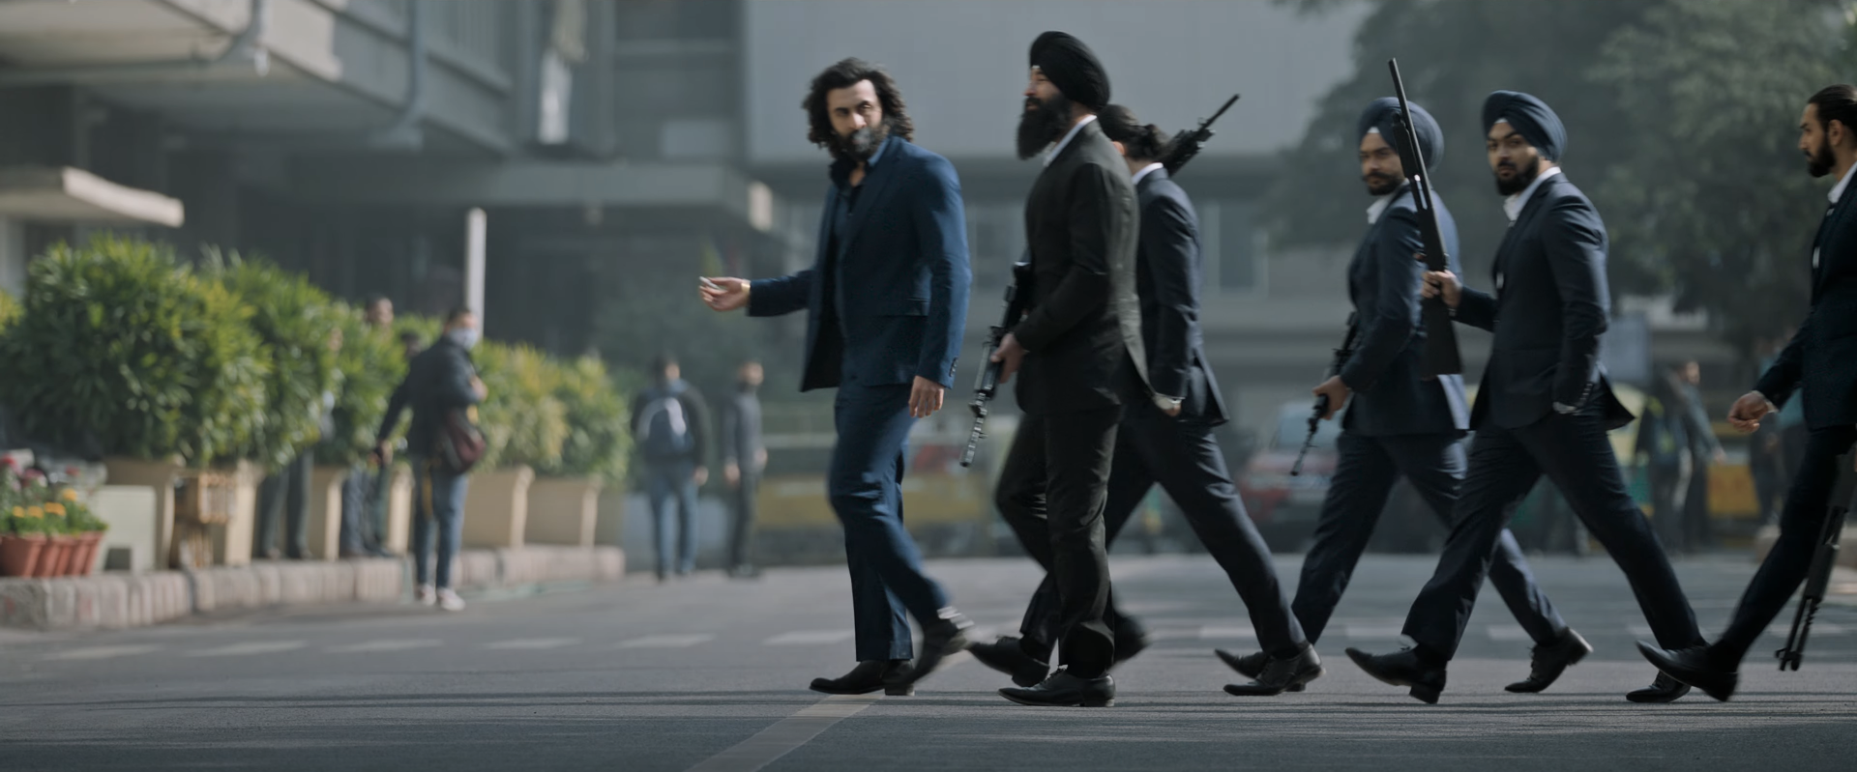
- other option is that we have a moving platform on the stage. It turns and Ranbir is revealed to the audience
- third option is that he can do the “phata poster nikal hero” kind of entry

Rashmika, Anil Kapoor and other cast should enter after a few minutes when the host announces their name.
Sandeep Reddy Vanga can enter in the end, making a grand entry for himself as the public is as excited for the director as the cast.
On the stage there can two two big props. On the left can be the gatling gun Ranbir uses in the film. A replica, of course. But of bigger size, not to scale. On the right can be a big axe, about 6 feet in size.

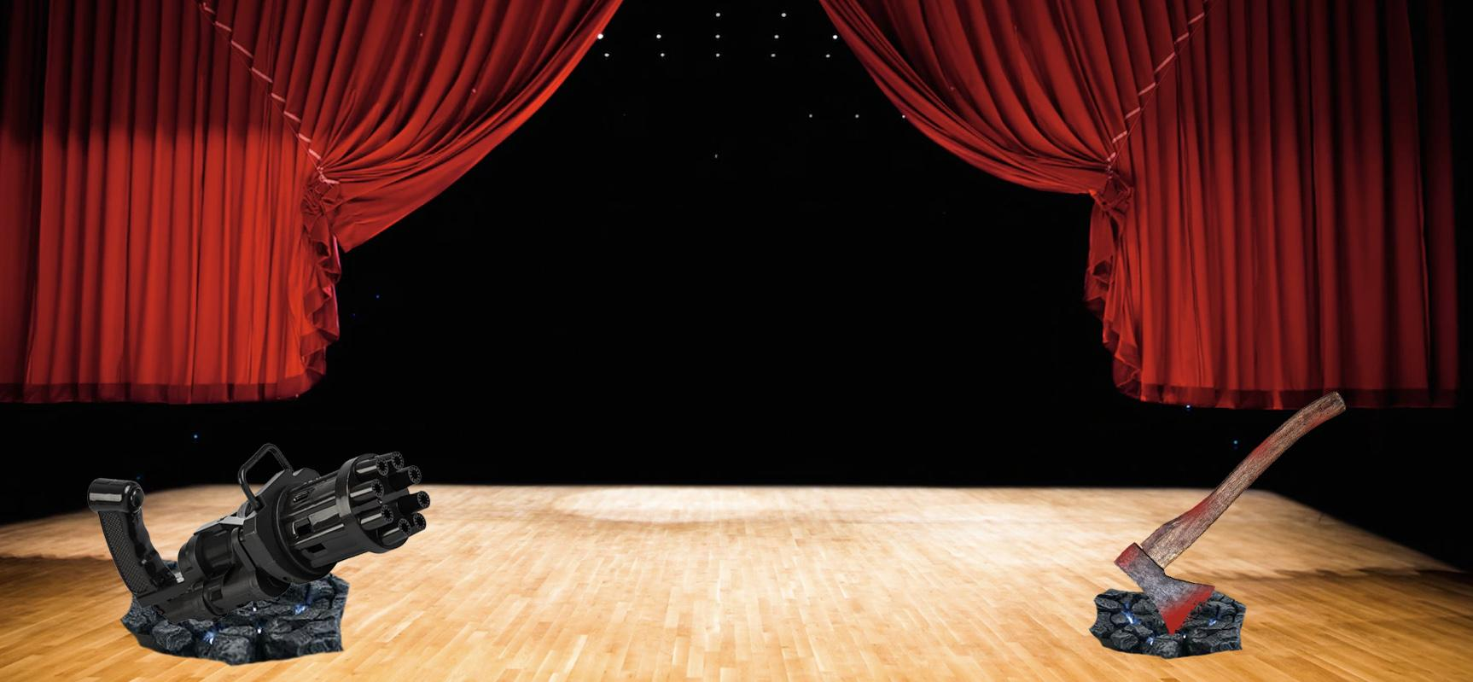
For prop designs, you can contact Prasun Basu’s lab and studio. He designed the astras for Brahmastra. www.offish.co.in

Costumes

Ranbir may wear one of the two outfits from the teaser/trailer. Either the blue suit or white kurta. A wig is also a possibility. But all these will depend on the logistics and availability as per the time.
It would be nice if everyone is in traditional attire.
Rashmika can be in a saree while the men can be in designer kurtas.
Ranbir needs to stand out, so the blue suit or a white kurta with blood stains.
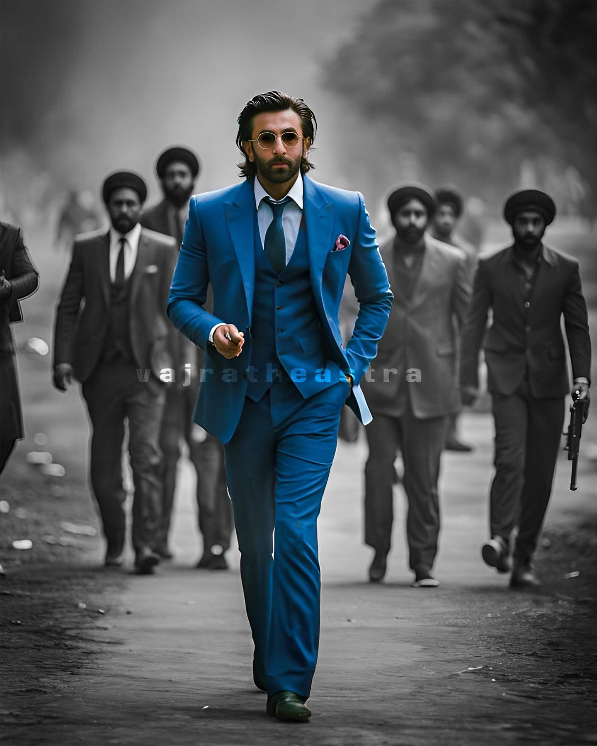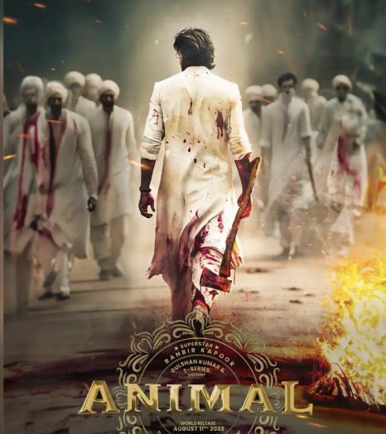

It may look like a lot of work for the trainer launch. But it is all about making an impact and standing out. The more dramatic the presentation is, the more it will connect with the audience, the theme of the film and would give the media something more to talk about than just the trailer.

Similar to how organizing Adipurush launch at a grand scale made the impact.

